Project Report

**Design a RC Model with Ultrasonic Obstacle Detection and Avoidance Radar System**



Amrita Viswa Vidyapeetham

Centre for Excellence in Computational Engineering and Networking

Prepared by : Pranavan Bupathy

Abstract:

This project is aimed at designing a small scale RC model car which is controlled by microcontroller and the movement of the RC is controlled through Bluetooth connected phone interface. A phone virtual joystick will be used by the user to control the movement of the RC model. In addition to this system, the RC is mounted with ultrasonic sensor on the top of the RC. The ultrasonic sensor acts as the Radar system that help to detect the nearby object with help of that detection the RC is prevented from collision from the nearby object during the control of the RC car. This acts as a safety system that helps to save the RC car from collision. In real life the autonomous cars have such systems which help the control system to learn about the environment and with that information the cars are driven safely This system helps the autonomous car with the safety measures by detecting the nearby cars and by helping to maintain distance in heavy traffic situation. The idea of this project is to replicate and replace the autonomous car with sensors as it is used in real autonomous car LIDAR system for best results. This can act as a breakthrough in technology showing the future way of transportation system and resources that will be available in future. This system helps to improve the performance of the autonomous car system and by AI it improves the performance of the vehicle movement.

Introduction:

In today's world where everything is evolved by AI, the automotive field has also seen advancements with new automation techniques. One of such endeavors is the autonomous car which has evolved over the years, trying to get getting better every day. With this inspiration, this topic aims to showcase those functionalities in a small scale RC model. Another innovation is the use of microcontrollers, which are reliable and useful to do the work in an efficient way. The idea of the project is to use Arduino as the microcontroller and program it to demonstrate the system.

Requirements:

For this project the hardware requirements are

* Arduino UNO
* Male and female jumper wires
* Servo motor
* Ultrasonic sensor
* RC car chassis
* RC wheel
* Motor driver
* Geared motor
* Battery
* Bluetooth module

Then software requirements are

* Arduino IDE software
* App created from MIT app Inventor.

**Arudino Uno:**

Arduino are microcontroller which is programmed by open source software and there are different types of arduino board available in market.It is equipped with analogue and digital pin which may be interfaced with various expansion board.Arduino uno is used as microcontroller in this project.Design of arduino looks as shown in figure 1 .below

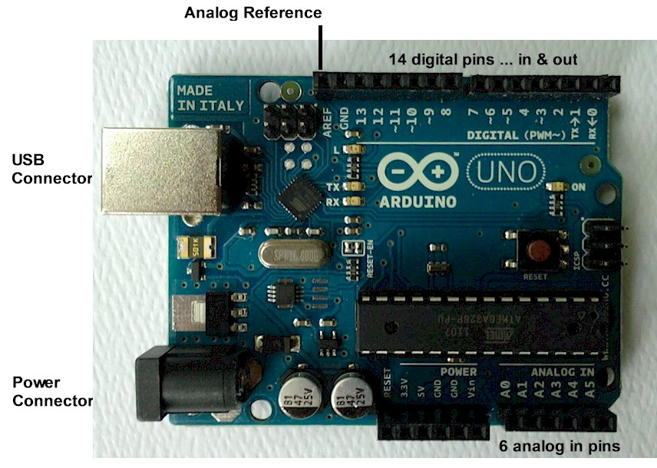

Figure 1. Arduino Uno board

**Servo motor:**

Servo motor is an electrical device which can rotate or push an object with great precision. This helps to rotate the ultrasonic sensor to 180 degree which helps to detect object around the rover and it helps to replicate the functionality of radar system.It works with Pulse Width Modulation which is rotation is controlled by the duration of applied pulse to its control pin.The yellow wire is connected to arduino input pin and red for 5v and brown is connected to ground.

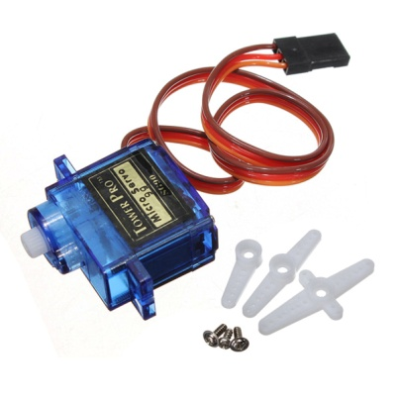

Figure 2. Servo Motor

**Ultrasonic sensor:**

RADAR (Radio detection and ranging) it is a detection system that uses radio waves to determine the range, angle, velocity of objects. Application are to detect aircraft, ship, spacecraft, guided missiles. The working of a radar system : It passes radio signal towards the object and the signal hits the object and signal is reflected back. With the time interval the distance of the object is calculated. Ultrasonic sensor function in the same way and the obstacle is detected by the sensor and with the input the vehicle is programmed to stop and avoid collision.

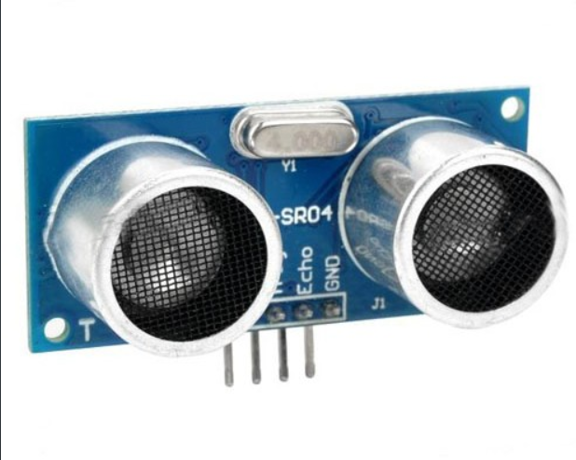

Figure 3. Ultrasonic Sensor

**Geared Motor:**

Geared motor are driving device used to move the rover in which it has geared setup to rotate at varying speed. According to the input voltage the speed of the motor is set and it can vary from 0 – 12v.The motor can rotate at 120rpm with full voltage .Voltage are passed through driver then driver control the voltage and passes the voltage to particular motor.

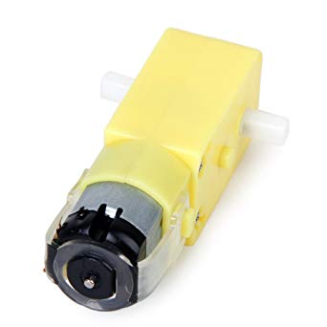

Figure 4.Geared Motor

**Motor Driver:**

An H-Bridge motor driver is an electronic circuit that switches the polarity of a voltage applied. This helps to control the rover to steer right, left and move forward and backward. By varying and polarising the motor we are able to control the rover Circuit of H-Bridge looks as shown below.

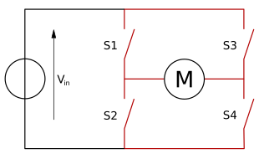

Figure 5. H-bridge

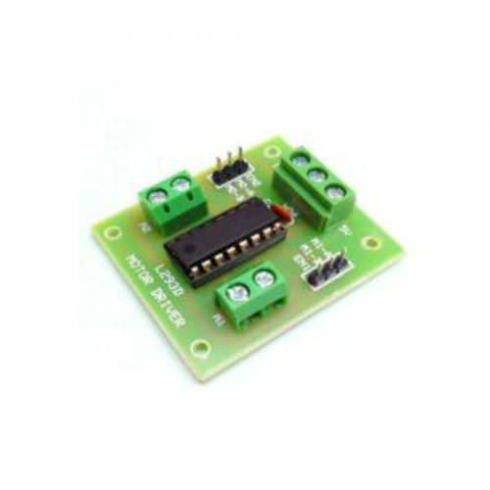

Figure 6 . Motor Driver

**Bluetooth Module:**

H-05 module is an easy to use Bluetooth (serial port protocol) module used for transparent wireless setup. It can be used as slave and master according to the application or need. This Bluetooth module is v2.0 with 2.4Ghz radio transceiver. Module has Tx transmission ,Rx Recieving pin ,vcc , gnd which are connected through Arduino.

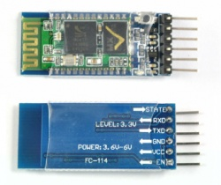

Figure 7. Bluetooth Module H-05

**Methodology:**

* According to the setup the input is given through the app which is anyone of these (Forward,Backward,Left,Right,Stop).
* The input is given through app which is connected with Bluetooth slave and the input value are given by signal
* Arduino read the input value and map the value to the analogue signal and passes the value to the driver
* The rover is made with two wheel setup which is connected to the motor driver.
* Motor driver that has H-Bridge system that helps to control the voltage to the motor
* Input from arduino is in the form of voltage from 0 -12 v then according to the value H-Bridge works
* Ultrasonic sensor that sense the distance which is synchronized to the movement of servo motor with that loop is setup if the distance is less than 150 then it execute the stop operation and the objective is achieved by avoiding the collision.
* Architecture shows the basic method that is happening in the system.

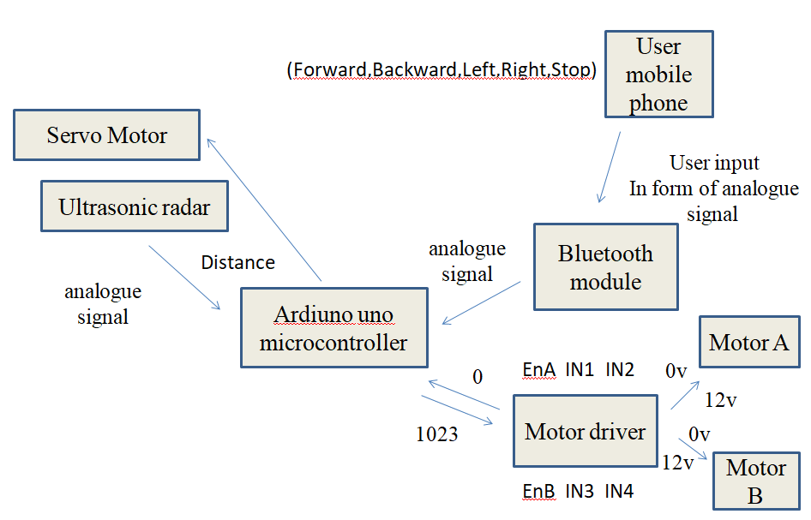

Figure.8. Architecture and flow diagram

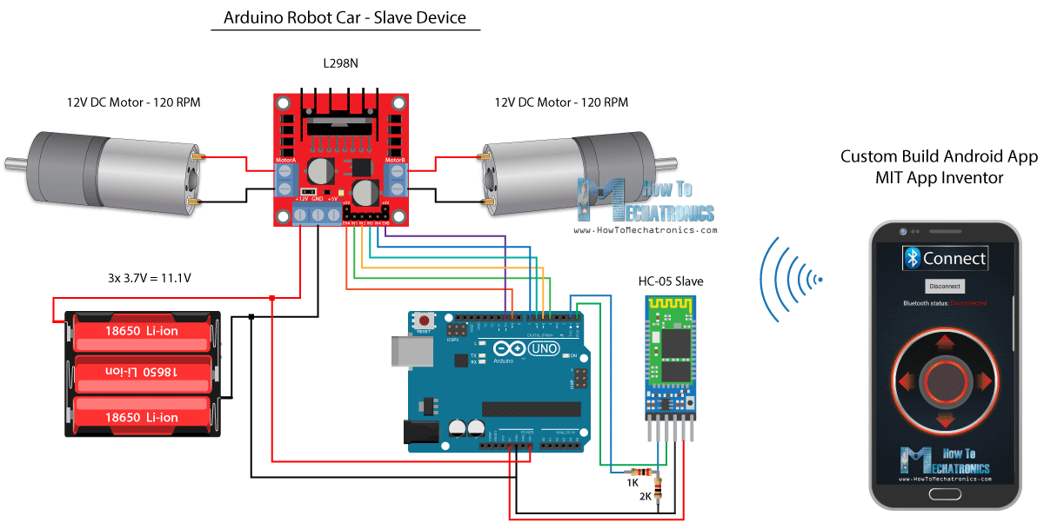

Figure 9. Circuit Diagram

**Conclusion:**

Today’s autonomous vehicle has some similar working method which is shown in this model car and some other feature can be added in future work like after obstacle detection it can steer to either side and proceed on. Thus this is still evolving over time so as available source it is possible to test with small model.